TEAM MEMBERS:

B SRI VAISHNAVI(SE21UCSE038)

PADMINI YENDAL(SE21UCSE140)

**SKIN LESION CLASSIFICATION OF DERMOSCOPIC IMAGES UDING MACHINE LEARNING AND CONVOLUTIONAL NEURAL NETWORK**

Problem Statement:

The problem of skin lesion classification using dermoscopic images involves developing a machine learning model, specifically a Convolutional Neural Network (CNN), to automatically classify skin lesions as benign or malignant. Early detection of skin cancer, particularly melanoma, is crucial for improving treatment outcomes, and automating this process through image analysis can assist dermatologists in diagnosis.

DATASET:

- The suggested approach makes use of the HAM10000 dataset, which has 10015 photos. The HAM10000 dataset is a sizable collection of dermoscopic pictures of common pigmented skin lesions from various sources.

- They are initially altered for color reproduction and visual contrast, and they are carefully trimmed and cantered around the lesion. Age, sex, lesion id (a unique identifier for a specific type of lesion), image id (a unique identification number for an image), dx type (for technical validation), the geographic location of the skin lesion, and a diagnostic skin lesion category (a classification of skin lesions that can be used to diagnose) were the seven features that were present in each image and patient.

Different types of skin lesions:

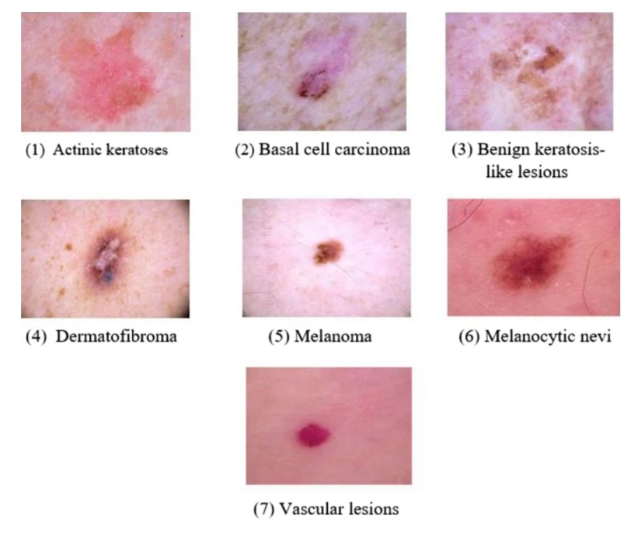

* **Actinic Keratoses (AK)**
* **Basal Cell Carcinoma (BCC)**
* **Benign Keratosis-like Lesions (BKL)**
* **Dermatofibroma**
* **Melanoma**
* **Melanocytic Nevi**
* **Vascular Lesions**

Proposed Methodology:  
  
We used machine learning and specially designed convolutional neural networks to create a completely automated method for identifying and categorizing skin lesions. The suggested effort focused on classification and pre-processing. The suggested study makes use of the standard HAM10000 dataset, which comprises 10015 skin lesion photos categorized into seven groups. The steps of the suggested work are shown in the below picture.

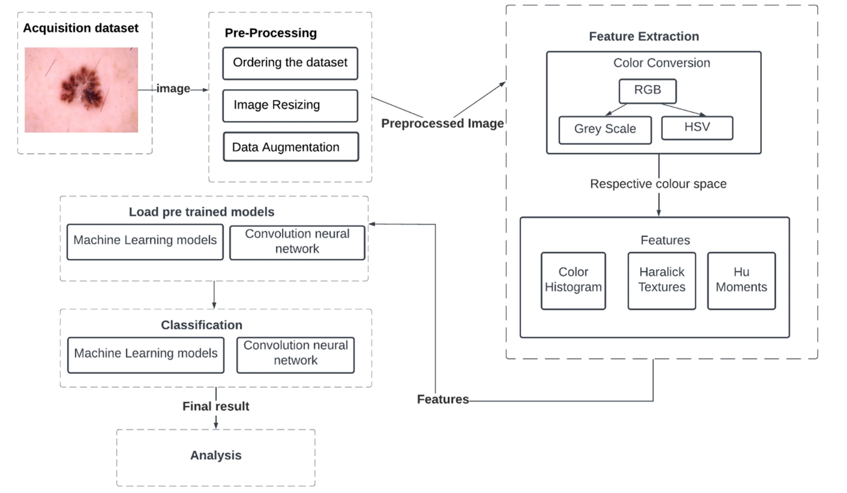

Flowchart of the ML Model.

### Image pre-processing

The following image pre-processing techniques were used in the suggested work.

#### **Step 1 - ordering the dataset**

It is important to sort each image within each folder by the seven diseases because the dataset images are out of order. In this case, the most important criteria for organizing the photographs were "image_id" and "dx." We find that the df skin lesion count in the dataset has the smallest size, at 115. To improve classification accuracy, it is therefore not enough to select 100 images for each class and train the model on a dataset of 100*7 images. More data will be produced as a result, and data augmentation will be employed to accomplish this.

#### **Step 2 - Image resizing**

1. Before being processed into various machine learning models, all of the photographs in the folder are resized to 220*220.

2. To expedite the process, photos are scaled to 96 × 96 x 3 for the bespoke CNN model. In order to determine the value of each pixel in the image, we then transformed the photos into a NumPy array. The pixel values were then adjusted to fall between 0 and 1. Class labels in string form in the dataset can be entered using the LabelBinarizer class, which then transforms them into one-hot encoded vectors and then back into a human-readable format using Keras CNN's integer class label prediction.

#### **Step 3 - Data augmentation**

1. Augmenting data is a method of creating new "data." The suggested technique included Horizontal Flip augmentation, which involves moving every pixel in a picture horizontally, to train the machine learning models. Therefore, compared to models without data augmentation, models with data augmentation are more likely to learn more distinguishing characteristic traits. We used a dataset of 200*7 photos to train the model, with 200 images from each class after augmentation. The sample images following Horizontal Flip augmentation.

2. Since each class contains 200 photos, we are working with a limited number of data points. Therefore, we have used random transformations (such as rotations and shearing) to train the CNN model. There were exactly as many photographs in each epoch as there were in the originals. Augmenting data also prevents overfitting.

Feature extraction

An entire image can be quantified using global feature descriptors. These process the full image since they lack the idea of interest points. A color histogram is used to quantify the skin lesion image's color. Hu Moments are used to quantify the skin lesion's form. A Haralick Texture is used to quantify the skin lesion's texture. Since color, shape, and texture are the only characteristics that stand out in the lesion zone, these qualities were selected. One image at a time is used in the feature extraction experiment, which extracts three global features, concatenates them into a single global feature, and saves the result in HDF5 format along with its label.

Data Splitting

The machine learning models were validated using the OpenCV program. For the purpose of training a machine learning model, 700 photos in total (100 images each class) were taken from the HAM10000 dataset; 560 of these images represent 80% of the training set, and 140 represent 20% of the testing set. This was required because the data set showed a significant class imbalance. Following dataset augmentation, 1400 photographs—200 from each class—are used to train the machine learning model, with 1120 images making up 80% of the training and 280 images making up 20% of the testing.

Image Classification

The machine learning models, and convolutional neural network model were utilized in the proposed study to train and test the picture dataset. The performance was assessed using a number of measures, including F1-score, Accuracy, Precision, and Recall. Several machine learning models, such as Decision Tree (DT), Random Forest (RF), Support Vector Machine (SVM), K-Nearest Neighbor (KNN), Logistic Regression (LR), Gaussian Naïve Bayes (NB), and Linear Discriminant Analysis (LDA), were employed in the proposed work. Ultimately, we compared the models based on evaluation parameters. The Table below displays the hyperparameters that the machine learning algorithms employ.

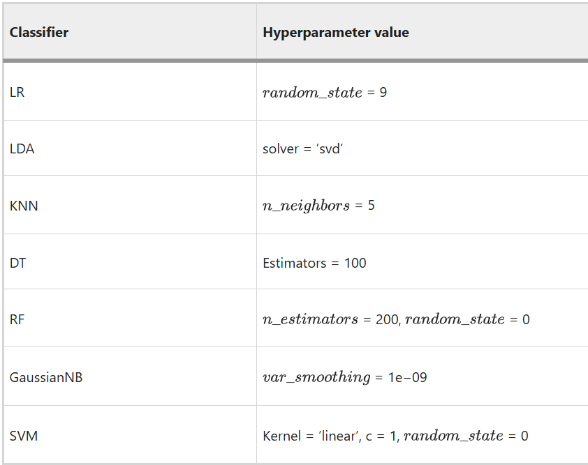

Results:

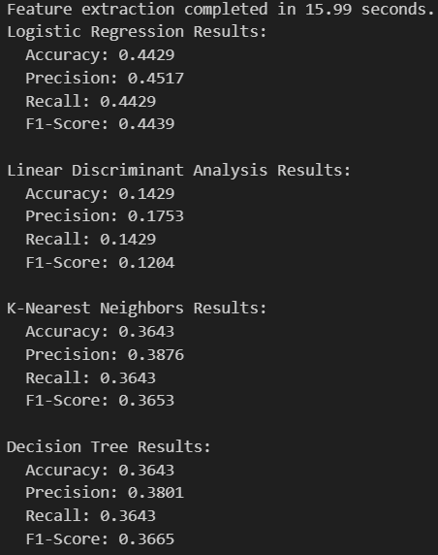

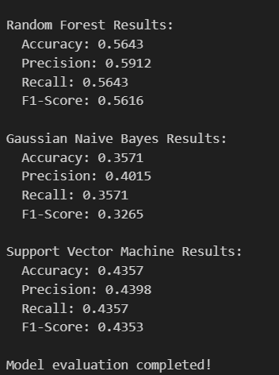

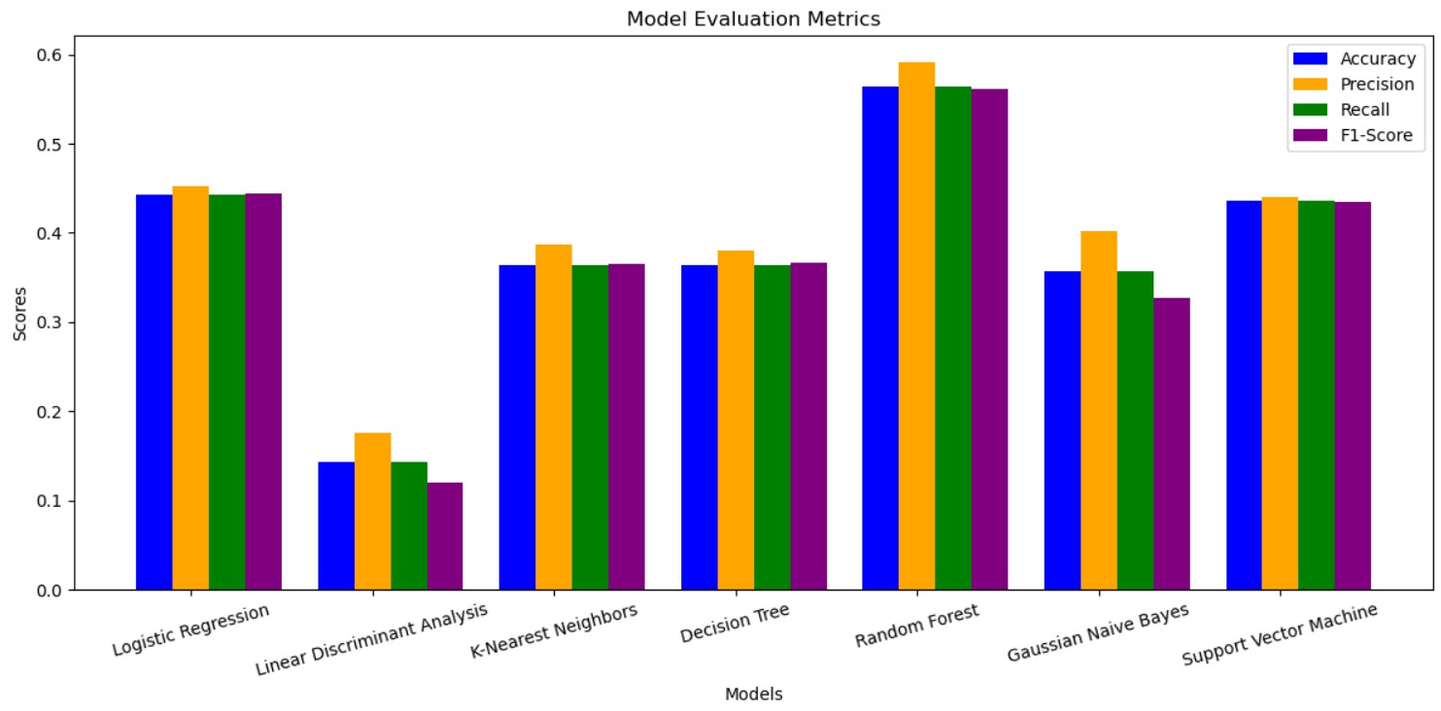

Convolutional neural network

Unlike a typical neural net, a CNN applies filters to an image's raw pixels in order to identify intricate patterns. Tensorflow and Keras packages were utilized to construct and execute the CNN model. The below figure provides a high-level overview of the CNN architecture. The table below provides a summary of the network's layers and hyperparameters.

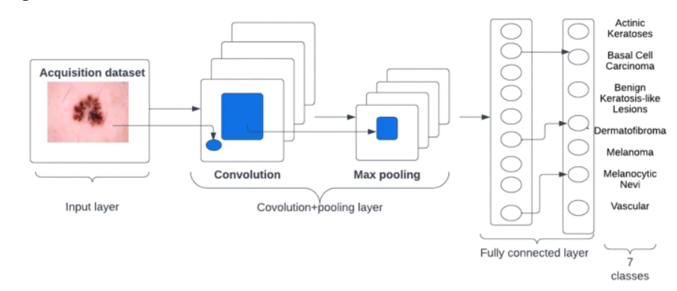

An Overview of CNN Architecture

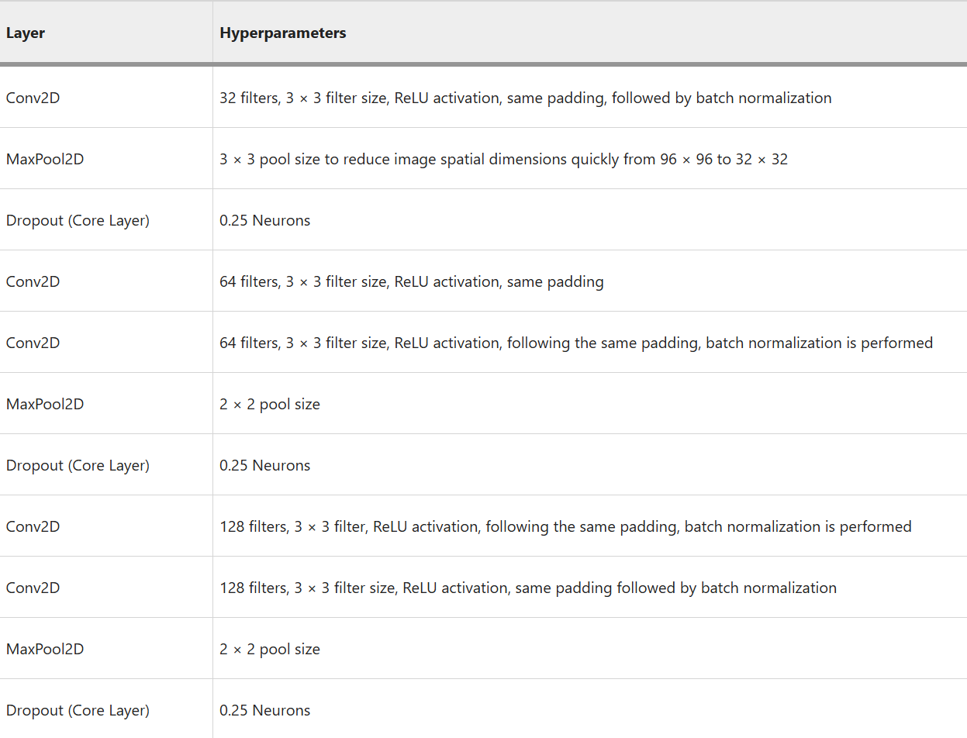

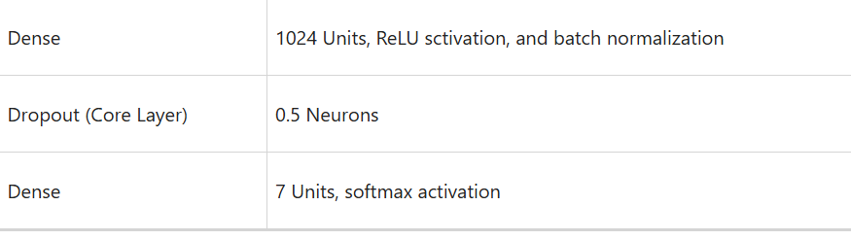

Model Hyperparameters

Some typical hyperparameter values are utilized to improve the model evaluation. The hyperparameter values were selected for the proposed study due to its ease of use, computational efficiency, and effectiveness while handling massive volumes of data and parameters, Adam is now the most used optimization technique for training deep neural networks. Function of Loss: The "categorical cross-entropy" loss function is used by the Multi-Class to determine the loss value. Periods: There are 20 epochs. Through experimentation, we discovered that 20 epochs produce a model with low loss and no overfitting to the training set (or as close to not overfitting as possible).

Results:

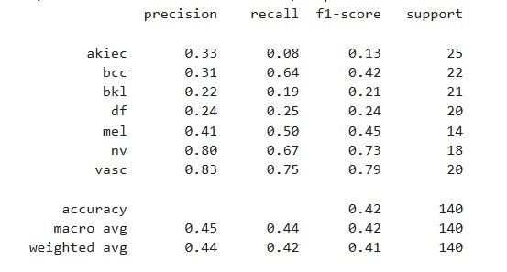

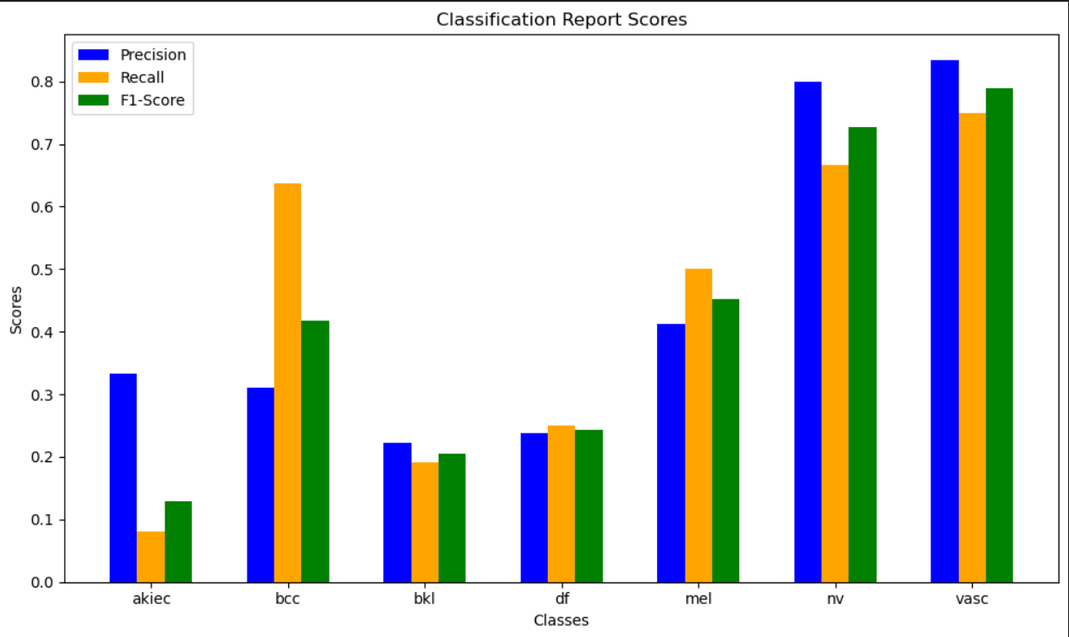

CNN Model’s Accuracy/loss.